# STRINGS IN C++

# 1) String Concatenation

The + operator can be used between strings to add them together to make a new string. This is called **concatenation**:

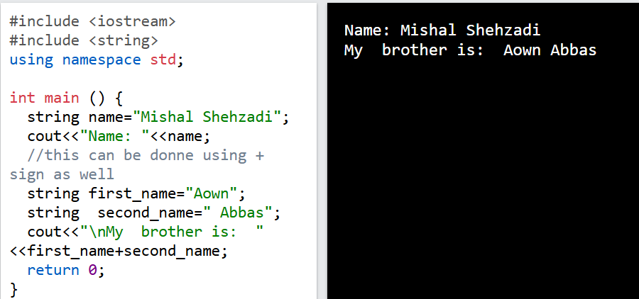

Append ():

A string in C++ is actually an object, which contain functions that can perform certain operations on strings. For example, you can also concatenate strings with the append() function:

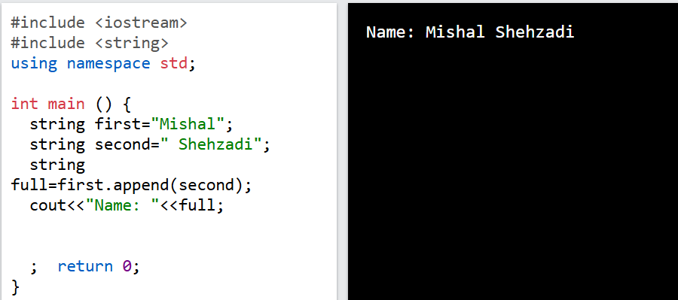

2) String Length

To get the length of a string, use the length() function:

3) Access Strings

You can access the characters in a string by referring to its index number inside square brackets [].

To print the last character of a string, you can use the following code:

4) Strings - Special Characters

5) User Input Strings

6) Omitting Namespace

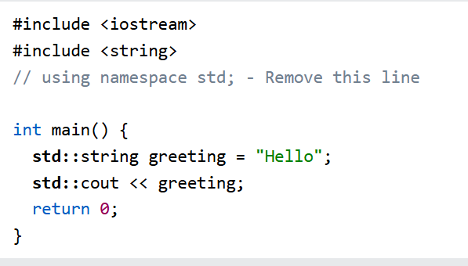

7) C-Style Strings

C-style strings are created with the char type instead of string

# Task:

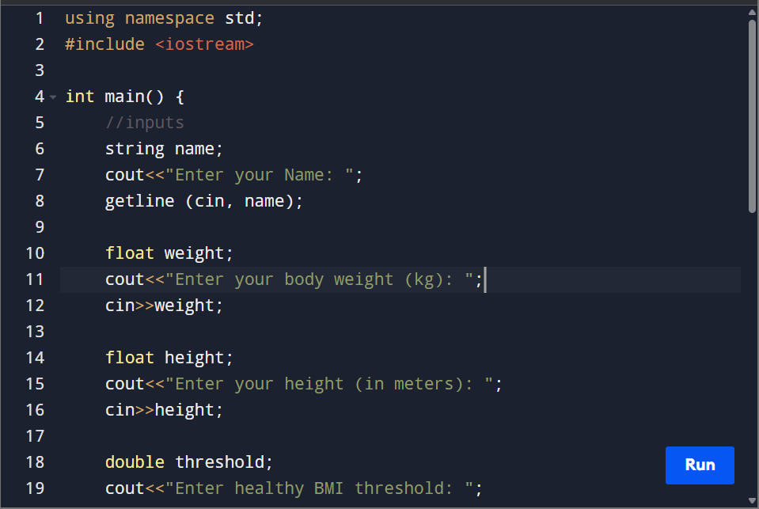

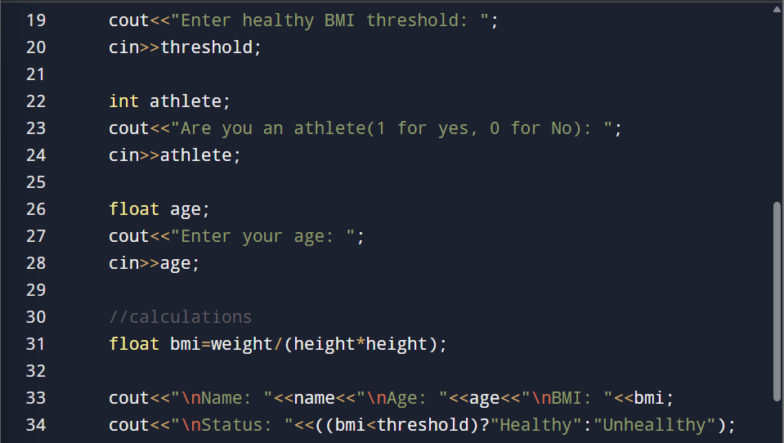

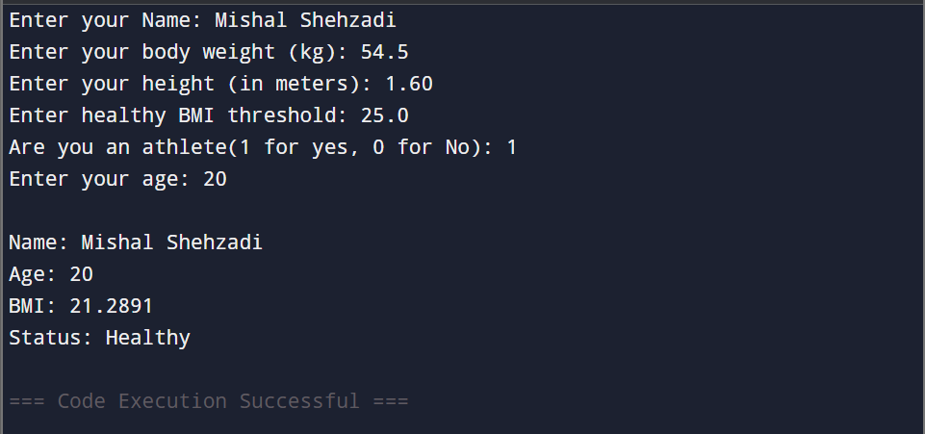

Task 02:



